Case study 1
A primigravida at term is admitted to a primary-care perinatal clinic at 06:00 with a history of painful contractions for several hours. She received antenatal care and is known to be HIV negative. The maternal and fetal conditions are satisfactory. On abdominal examination a single fetus with a longitudinal lie is found. The presenting part is the fetal head, and 4/5 is palpable above the brim of the pelvis. 2 contractions in 10 minutes, each lasting 15 seconds are noted. On vaginal examination the cervix is 1 cm long and 2 cm dilated. The fetal head is in the right occipito-posterior position.

1. Is the patient in active labour?
No. The cervix is less than 5 cm dilated. The patient is, therefore, still in the latent phase of labour.

2. How should you enter your findings on the partogram?
As the patient is still in the latent phase of labour, the descent and amount of fetal head palpable above the brim, the presenting part and the position of the head, and the length and dilatation of the cervix, must be recorded on the vertical line forming the left-hand margin of the latent phase part of the partogram. The correct way of entering the above data on the partogram is shown in figure 8C-7.

3. How should you manage this patient further?
The patient must have the routine observations (such as pulse rate, blood pressure and fetal heart) performed at the usual intervals. She must be offered analgesia and sedation. Adequate analgesia, e.g. pethidine 100 mg and promethazine 25 mg or hydroxyzine 100 mg, should be given by intramuscular injection as soon as the patient asks for pain relief. A second complete examination should be done at 12:00, i.e. 6 hours after the first complete examination. The patient must be encouraged to walk about as this will help the progress towards the active phase of the first stage of labour.
At the second complete examination the maternal and fetal conditions are satisfactory. On abdominal examination 2/5 of the fetal head is palpable above the brim of the pelvis. 3 contractions in 10 minutes, lasting between 30 seconds each, are noted. On vaginal examination the cervix is 2 mm long and 6 cm dilated. The head is in the right occipito-anterior position.

4. Is the patient still in the latent phase of labour?
No. The cervix is more than 5 cm dilated. The patient is, therefore, in the active phase of labour.

5. Where should you enter the findings obtained at 10:00?
The findings must be entered on the latent phase part of the partogram, 6 hours to the right of the findings at 06:00. However, as the patient is now in active labour, the data must then be transferred to the active phase part of the partogram. This must be indicated with an arrow.

6. How should you transfer the findings at 12:00 from the latent to the active phase part of the partogram?
The X (cervical dilatation) must be moved horizontally to the right until it lies on the alert line. This will again be at 6 cm dilatation. The O (number of fifths of the head above the pelvic brim) is similarly transferred to lie on the same vertical line on the vertical axis. The new position of the head (ROA) must be indicated on the O. The length of the cervix is recorded by a 5 mm thick black column on the base line vertically below the X and O. The fact that the membranes have been ruptured is entered in the block provided for medication/ I.V. fluids/management. A ‘C’ in the block provided for liquor indicates that the liquor is clear. The correct method of transferring the above findings from the latent to the active part of the partogram is shown in figure 8C-7.
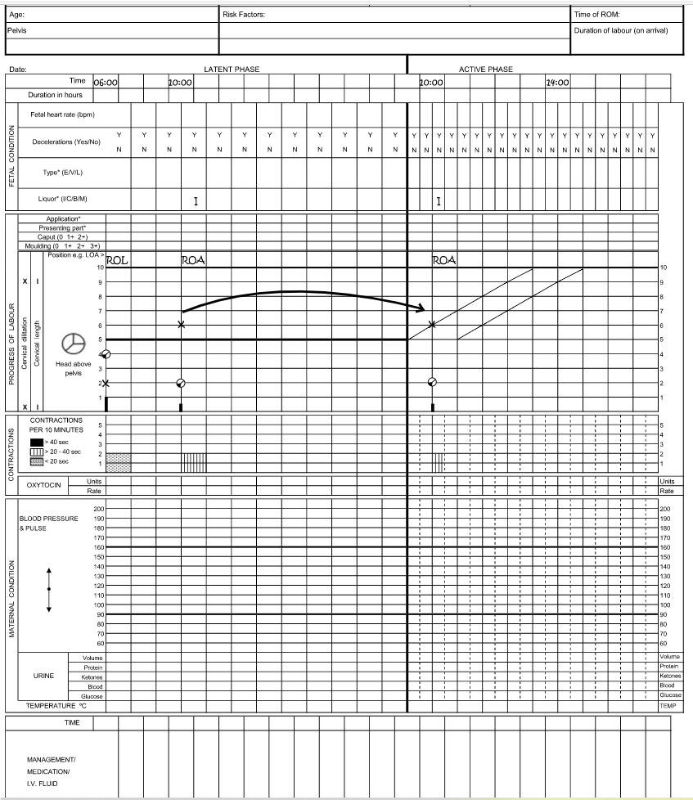

Case study 2
A multigravida is admitted to the labour ward at 08:00 in labour at term. She received antenatal care and is known to be HIV negative. The maternal and fetal conditions are satisfactory. On abdominal examination the head is 4/5 palpable above the brim of the pelvis. 3 contractions in 10 minutes, each lasting 25 seconds are noted. On vaginal examination the cervix is 1 cm long (and thus not fully effaced) and 5 cm dilated. The presenting part is in the left occipito-posterior position. The patient complains that her contractions are painful.

1. Is the patient in the active phase of labour?
Yes, as the cervix is more than 5 cm dilated.

2. How should you record your findings?
As the patient is in the active phase of labour, the findings must be entered on the active phase part of the partogram. The X (cervical dilatation) is recorded on the alert line, opposite the 5 on the vertical axis indicating 5 cm dilatation. The O (number of fifths palpable above the pelvic brim) is recorded below the X opposite the 4 on the vertical line. The length of the cervix is recorded by a 1 cm column on the base line, vertically below the X and O. The correct way of recording the above findings is in figure 8C-8.

3. How should you manage the patient further?
The routine observations (e.g. pulse rate, blood pressure, fetal heart, and urine output) must be performed at the usual intervals. The patient must be offered analgesia. Pethidine 100 mg and promethazine 25 mg or hydroxyzine 100 mg should be given by intramuscular injection as soon as the patient requests pain relief. A second complete examination should be done at 12:00, i.e. 4 hours after the first complete examination.
At the second complete examination the maternal and fetal conditions are satisfactory. On abdominal examination the head is 3/5 palpable above the brim of the pelvis. 3 contractions in 10 minutes, each lasting 25 seconds, are noted. On vaginal examination the cervix is 5 mm long and 6 cm dilated with bulging membranes.
The presenting part is in the left occipito-transverse position. Poor progress is diagnosed and a systemic assessment of the patient is made in order to determine the cause. Intact membranes and inadequate uterine contractions are diagnosed as the causes of the poor progress.

4. How should you record these findings on the partogram?
The X must be recorded on the horizontal line corresponding to 6 cm cervical dilatation, 4 hours to the right of the record at 08:00. The position of the fetal head and length of the cervix are recorded on the same vertical line as the X. The correct way of recording these observations is shown in figure 8C-8.

5. Is the progress of labour satisfactory?
No. This is immediately apparent by observing that the second X has crossed the alert line. For labour to have progressed satisfactorily, the cervix should have been at least 9 cm dilated (5 cm initially plus 1 cm per hour over the past 4 hours).

6. How should you manage this patient further?
The membranes must be ruptured. Rupture of the membranes will result in stronger uterine contractions. Because there has been inadequate progress of labour, a third complete examination should be performed at 14:00, i.e. 2 hours after the second complete examination.
At the third complete examination the maternal and fetal conditions are satisfactory. On abdominal examination the head is 1/5 palpable above the pelvic brim. 4 contractions in 10 minutes, each lasting 50 seconds are observed. On vaginal examination the cervix is 1 mm long and 9 cm dilated. The presenting part is in the left occipito-anterior position. The findings are recorded as shown in figure 8C-8.

7. What is your assessment of the progress of labour at 14:00?
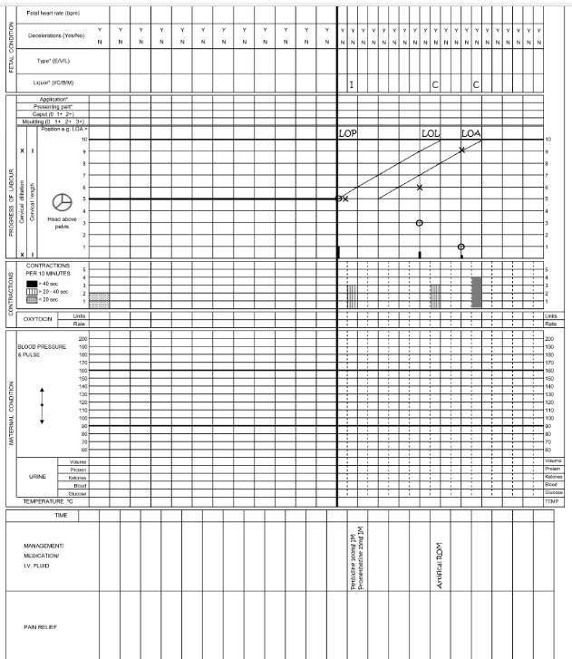
Labour is progressing satisfactorily. This is shown by the third X having moved closer to the alert line. The head, which has rotated from the left occipito-posterior to the left occipito-anterior position, is also engaged. A spontaneous vertex delivery may be expected within an hour.

Case study 3
A gravida 2 para 1 is admitted to the labour ward at 09:00 in labour at term. She has already had painful contractions for the past 2 hours. Two years before she had a vacuum extraction for a prolonged second stage of labour. The infant’s birth weight was 3000 g. The maternal and fetal conditions are satisfactory. On abdominal examination the head is 4/5 palpable above the brim of the pelvis. The cervix is 2 mm long and 6 cm dilated. There is 1+ of moulding present and the presenting part is in the right occipito-posterior position. The patient is HIV negative and an artificial rupture of the membranes is performed and a small amount of meconium-stained liquor is drained. The patient is given pethidine 100 mg and promethazine 25 mg or hydroxyzine 100 mg. A second complete examination is scheduled for 11:00.

1. How should you record the above findings?
As the patient is in the active phase of labour, the findings must be entered on the active phase part of the partogram. The X (cervical dilatation) is recorded on the alert line opposite the 5 on the vertical line. The other findings are entered in their appropriate places as shown in figure 8C-9.

2. Is the decision to schedule the next complete examination at 11:00 correct?
Yes. There are early signs of cephalopelvic disproportion (1+ moulding) on admission.

3. What observations must be done carefully during the next 2 hours?
Meconium in the liquor indicates that the fetus is at an increased risk for fetal distress. Therefore, the fetal heart rate pattern must be observed carefully for signs of fetal distress (e.g. late decelerations).

4. What is likely to happen to this patient’s progress of labour?
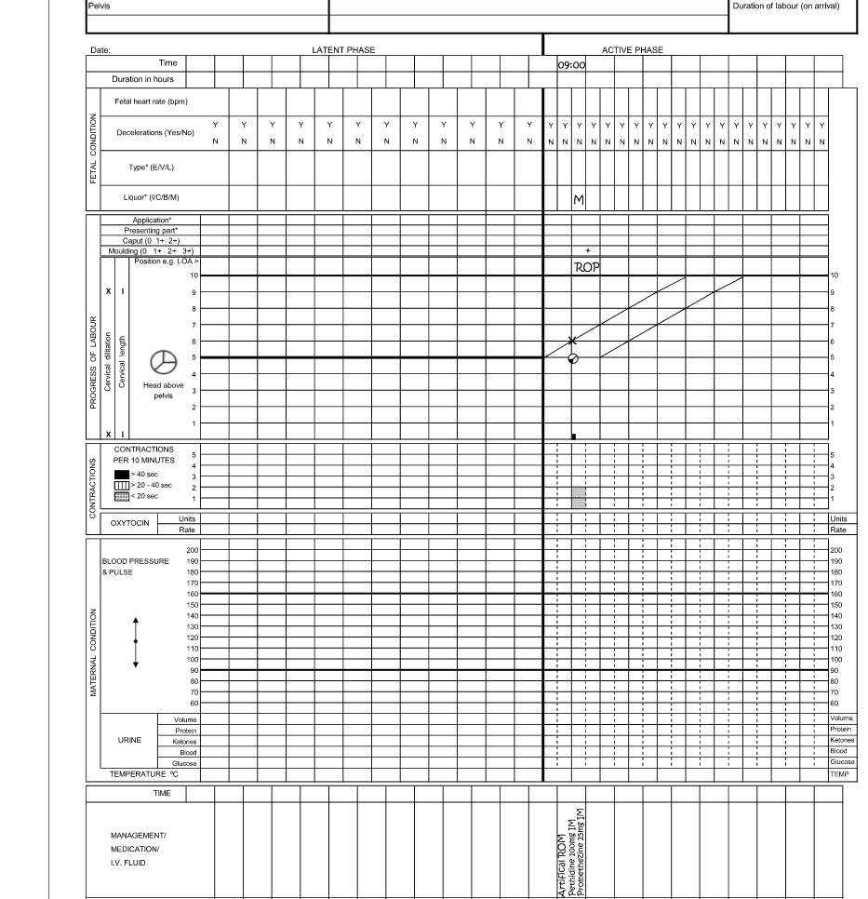
The most likely outcome is the development of cephalopelvic disproportion. On abdominal examination the head will remain 3/5 or more palpable above the pelvic brim (i.e. unengaged) and on vaginal examination there will be 2+ or more moulding. An urgent Caesarean section should then be performed.

